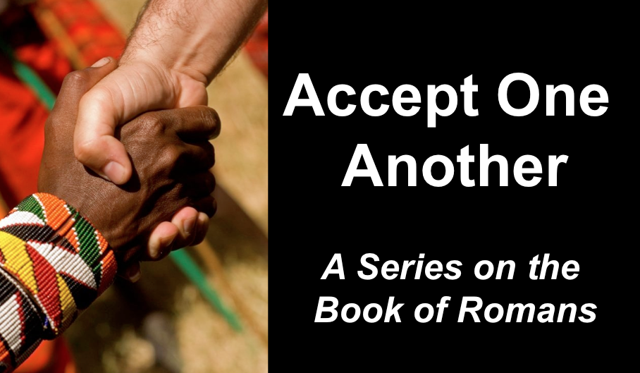
Righteousness Apart from the Law
Romans 3:21-31
Andrew B. Spurgeon
Crossroads International Church Singapore
Message 4 • 19 March 2017

Context:
- Jewish pilgrims to Jerusalem during the coming of the Holy Spirit at Pentecost, returned to Rome and established the churches in Rome (Acts 2:10). They included Gentiles in their worship and congregation. But Emperor Claudius expulsed all the Jews from Rome (AD 44–49), the founders of the church in Rome left and the Gentile Christians filled the gap in the leadership. In AD 54, Emperor Claudius died, and Nero became the new Emperor. Jews, including Jewish Christians, returned. Tensions arose in the churches over customs. So Paul’s message to them was, “Accept one another just as Christ has accepted you, for the glory of God” (Rom 15:7).
- But Paul wrote the letter in an evangelistic letter: detailing the need for the gospel (1:18—3:21), the gospel (3:21—5:21), and the practical implications of the gospel (chaps. 6–15).

Gospel:
- The gospel is a birth announcement and a victory announcement.
- The gospel requires a response.

Objection 1:
- I don’t need the gospel because I am not a sinner.
- Crime: They deny the Existence of God as evidenced by the creation! “Although they know God exists, they neither give glory to God nor thank him”
- Punishment:
  - God gave them over to their own desires [epithumia] of their hearts; they worship creatures (1:24–25)
  - God gave them over to dishonorable passions [pathos]; they confuse gender relationships (1:26–28)
  - God gave them over to thoughtless minds [nous]; they commit acts of wickedness and approve those who practice them (1:26–32)

Objection 2:
- I don’t need the gospel because I am a saint!
- God says, “You who pass judgment on someone else, for at whatever point you judge another, you are condemning yourself, because you who pass judgment do the same things” (2:1); On the other hand, God’s judgment is based on truth (2:2); so those who judge others, but do the same act, will not escape God’s judgment (2:3).
- Their crime: Showing contempt for God’s kindness; that is, instead of taking advantage of God’s kindness and repenting, they were being arrogant in their self-righteousness, not thinking of God or the need for God (2:4).

Objection 3:
- I don’t need the gospel because I am privileged (I have the law and circumcision)
- Their crime # 1: They do the same things that they speak against (2:17–24).
- Their crime # 2: Circumcision has value if you observe the law, but if you break the law, you have become as though you had not been circumcised (2:25–29)

Objection 4:
- I don’t need the gospel because I am not totally depraved.
- Paul: “There is no one righteous; not even one; there is no one who understands, no one who seeks God. All have turned away . . . There is no fear of God before their eyes” (3:10–18)

Righteousness of God: Genesis 19:19; 20:5; 30:33 tell us that we are talking about “uprightness” of God, i.e., “What proves God is trustworthy?” or “What proves God kept his role as the Creator God who took the first step towards redeeming his creation, the people?”

- God is upright because salvation rests on faith (1:17), i.e., apart from the law (3:21) although testified by the law and the prophets (3:21)
- God is upright because salvation is by the faithfulness of Jesus Christ (3:22)
- God is upright because salvation is offered to everyone who believes, without distinction—all have sinned (3:22–23)
- God is upright because salvation is a free gift based on God’s grace and redemption that is in Christ Jesus (3:24)
- God is upright because he appointed Jesus as the “mercy seat” because of Jesus’s faithfulness, in his blood—demonstrations of his uprightness (3:25a)
- God is upright because he overlooked [through Jesus’s work] sins committed beforehand (3:25b)
- God is upright because in his patience he demonstrates his uprightness in the present time, that is, by being the Judge and the one who justifies people by Jesus’s faithfulness (3:25b)

Conclusion: No chance for anyone to boast! (3:27)

Download this sermon PPT and notes for free at BibleStudyDownloads.org/resource/new-testament-preaching/
Listen to this message online at cicfamily.com/sermon-listing/

